Name:

Give an example of each of the following concepts in the dart language. Write the code, screenshot it and add it to this document:

1. Declaring a variable that takes characters: (String)

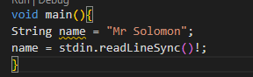

1. Declaring a variable that only takes whole numbers: (Integer)

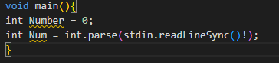

1. Declaring a variable that takes decimal numbers:(Double)

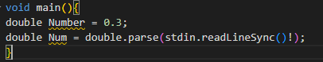

1. Declaring a variable that only takes true or false logical values:



1. Declaring a variable that refers to multiple values under the same name:(List or Map)

Lists

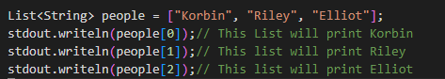

Map

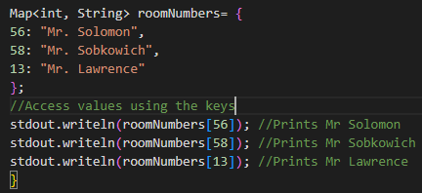

1. Printing a message using dart:io :(print or Stdout.writeln)



1. Printing a message only if a condition is met: (If statement)

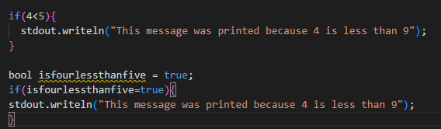

1. Printing an alternative message if a condition is not met:

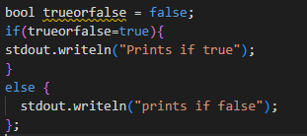

1. Using the switch statement:

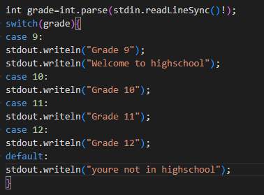

1. Repeating a statement 10 times using a for a loop:



1. Repeating a statement 10 times using a while loop:

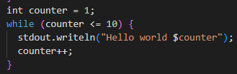

1. Printing the values of a list using a **For in** loop:

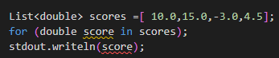

1. A function that takes **mandatory** parameters(input) and returns a string. (Write the code for the function and the code for calling it in void main):

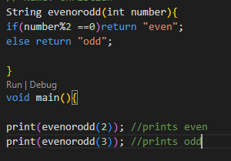

1. A function that takes **named optional** parameters (input) and returns a String. (Write the code for the function and the code for calling it in void main):

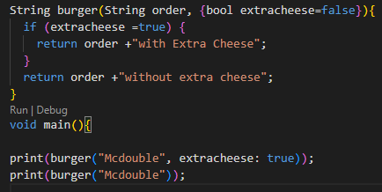

1. How to make a list using a while loop and a switch statement

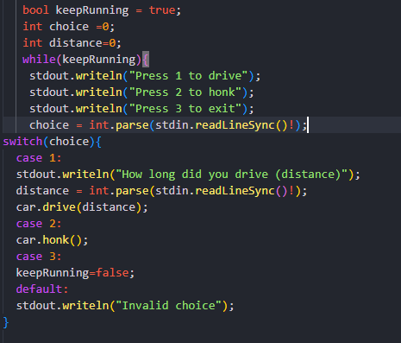

16. How to use “this” keyword in a constructor:

The word “this” refers to the class/object we are currently inside.

When using the “this” keyword, the properties do not need to be initialized.

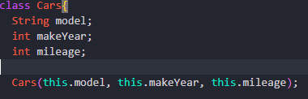

17. How to make a class inherit from another class

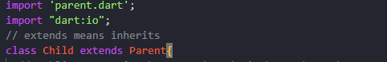

18. How to use the “super” keyword to access the public properties and functions of the parent class from within the child class.

**\*the super keyword only works inside of the constructor of the child class**



19. How to make a property private:

We make properties private by placing an underscore right before their names

makeYear is **public because it is missing the underscore**

_mileage is **private because it has the underscore**



20. How to access images from the assets of the app:

Step 1: Create assets/images folder in the same directory as the lib folder

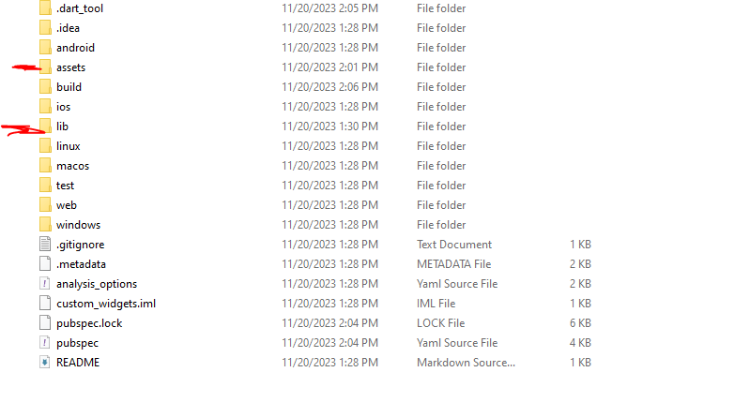

Step 2: download and put the picture in the images folder

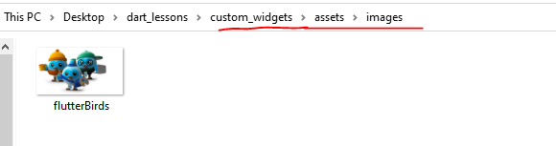

Step3 : Add the assets property to the pubsec.yaml file.

Remember: 2 white spaces before assets:

4 white spaces before the hypen

1 white space after the hypen

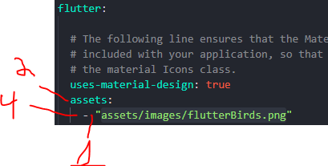

Step 4: use the Image.asset() widget in your code



21. How to use a conditional operator

<Boolean statement> **?** <What to do if true>  **:** <What to do if false>

